Lab 4 – Cell Tower Placement

## Background

GIS is used regularly in industry and government to determine the most appropriate placement of physical infrastructure such as cell phone towers. As cell phone use increases worldwide, the number of cell phone towers will also need to increase to support more usage. As with most site selection problems, geographic constraints on site selection, including proximity and terrain constraints can be used in a geoprocessing workflow model to identify potential locations for cell phone towers. In this laboratory exercise, you will create a model using ArcGIS Pro ModelBuilder that produces a map showing potentially optimal locations for new cell phone towers in Utah County, Utah, USA.

## Problem Statement

In the current atmosphere of instant messaging and social networks, people want to be able to connect to others whenever and wherever. This has become possible for many people through cell phones and their vast array of applications. The convenience of sharing experiences (e.g. Instagram) instantly and calling for help in times of need (e.g. car trouble) are only a couple of reasons why cell phone use is increasing.

Cell phone companies are continually competing to gain the greatest coverage by building new towers in both highly populated and rural areas of the country. It can be argued that the rural Western United States especially needs more cell phone tower coverage due to increasing population (U.S Census Bureau, 2011) and the growing trend of cutting land-lines. At the same time, cellular providers are for-profit companies with stockholders who expect careful planning decisions that increase revenue and lower costs. Hence it is important for companies to not build too many cell towers, while still gaining as much coverage as possible (and profitable).

Assume that you work for a multinational cellular phone company that is interested in expanding the extent of its coverage in the Western United States, including Utah County, Utah. As you might suspect, there are many factors that govern the placement of cellular phone towers. Some factors are based on physical requirements and others on political and economic issues. See the following website for further discussion on placement requirements:

* <http://www.arcelect.com/cell-cellular_antenna_installation_guidelines.htm>

Your task is to create an ArcGIS Pro ModelBuilder model that identifies the most suitable locations in Utah County for cell phone towers by using the three spatial considerations described below.

## Spatial Considerations

For the purposes of this exercise, you will limit the spatial considerations to the following:

Proximity to cell tower: Find locations with a density less than 20 cell towers per 10,000 square-kilometers (i.e. in a 100x100 km2).

Proximity to major roads: Find specific locations that are within 1 km of the I-15 freeway or any of the other named highways in Utah County.

Terrain slope: Usually towers can be constructed on a variety of slopes, however, flatter slopes are less expensive to build on and can also require shorter towers. Find locations with a slope of less than 5 degrees.

## Data

Cellular: <http://www.mapcruzin.com/free-wireless-gis-maps/cellular-shapefile.htm>

Click the **Download FCC Cellular Shapefile** to download the cellular shapefile for this project. This is a slightly outdated shapefile of cell towers across the United States but is suitable for the purposes of this exercise. If this link doesn’t work for you, any cellular shapefile you can find online can work for this lab.

Utah Counties Shapefile: <http://gis.utah.gov/data/boundaries/citycountystate/>

Find a shapefile that represents all the counties from Utah Under the **County Boundaries** section, download the **County Boundaries: Shapefile**.

UDOT Highways: <http://gis.utah.gov/data/sgid-transportation/roads-system/>

Find a shapefile that represents all the major roads and highways in Utah. Under the **Highway Linear Referencing System Routes** section, download the **UDOT LRS Routes: Shapefile.**

NED (National Elevation Dataset): <http://gis.utah.gov/data/elevation-terrain-data/10-30-meter-elevation-models-usgs-ned/>

Download an elevation dataset for Utah provided by the USGS. Open either **Raster App: 10-meter USGS DEMs** or **30-meter USGS DEMs**. Download the 10m or 30m NED for Utah County using any of the methods on the page.

## ModelBuilder Tools

You will use the following new tools in this exercise along with tools from previous labs:

Density: Calculates the density of the input features within a region around each output cell. Density is defined as the mass per unit volume. In this lab, you are looking for the number of cell phone towers for a given area.

Clip: An overlay operation (Bolstad, p. 357-358) where the input layer is cut based on the extent of the bounding layer. This operation preserves information from the input layer within the area of the bounding layer.

Kernel Density: Creates a smooth surface from points or polyline features using a kernel function. For more information, use the tool help and online resources to understand what this tool does.

## Example Model

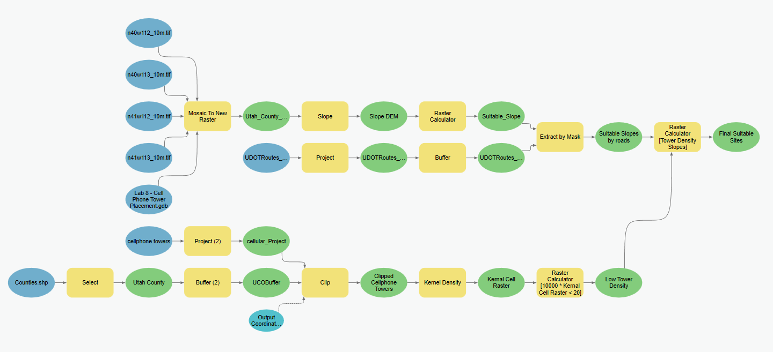

## Complete the Lab

For an advanced GIS student, the information up to this point is all you need to complete the assignment and create an output map from the results. Feel free to try conducting the analysis using only the information provided above. If you complete the lab only using the information provided above (without using the step-by-step instructions below) make sure to indicate this in your lab report to be considered for extra credit. If you need extra help, follow the step-by-step solution below.

## Step by Step Solution

### Step 1

If you have multiple have multiple raster tiles, use the **Mosaic To New Raster** tool to combine them. Set the output raster to the correct projection. If you have one tile, use the **Project Raster** tool to set it to the correct projection.

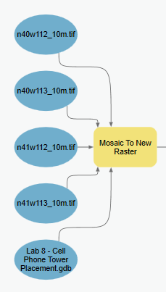

Figure 1: Mosaic to New Raster tool in Model Builder

### Step 2

Use **Slope** and the **Raster Calculato**r tools to identify the suitable slopes (i.e. less than 5 degrees). Use the following conditional statement in the Raster Calculator: **Con("%Slope_DEM%" < 5,1,0)**. This statement will assign a ‘1’ to the output grid with slopes that are less than 5 degrees and a ‘0’ to all other slope values.

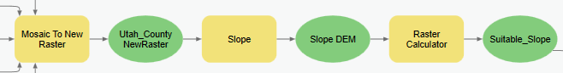

Figure 2: The Slope and Raster Calculator tools in Model Builder.

### Step 3

Use the **Buffer** tool to buffer the selected roads by **1 km**. Select **Dissolve On**. Make sure that the buffered roads shapefile is projected in **NAD 1983 Zone 12**.

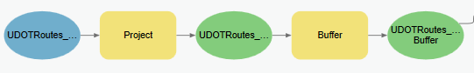

Figure 3: Using the Buffer tool for the UDOT Routes LRS shapefile

### Step 4

Use the **Extract by mask** tool to extract from the slope raster those areas that fall within the previously computed road buffers. Select the **Suitable_Slope** data layer to be the **Input Raster** and the **UDOTRoutes_LRS_Buffer** as the **Input raster or feature mask data.**

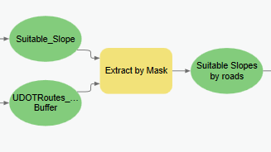

Figure 4 – The Extract by Mask tool in Model Builder.

### Step 4

Use the **Select** tool to select Utah County boundary. Use the SQL expression: “**NAME” = “Utah**” Use the **Buffer** tool to place a 50-mile buffer around the Utah County boundary.

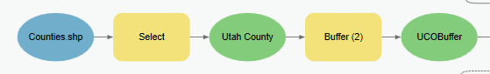

Figure 5 – Using the Buffer tool for the County shapefile.

### Step 5

Use the **Project** tool to make sure the cell tower layer is projected in **NAD 1983 UTM Zone 12N.**

Use the **Clip** tool to clip the cell phone towers point shapefile with the buffered Utah County layer to create a new layer of towers only in and around the county.

You can also project the Cell Tower shapefile with the **Clip** tool. To change the output projection, right-click the tool and select **Make Variable**, **From Environment,** then click **Output Coordinate System**. This will display a lighter blue bubble that you can open and browse for the correct coordinate system.

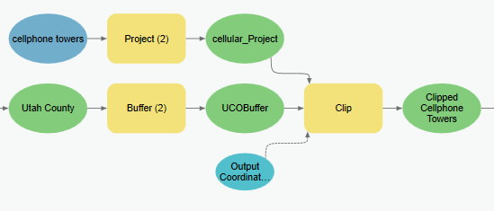

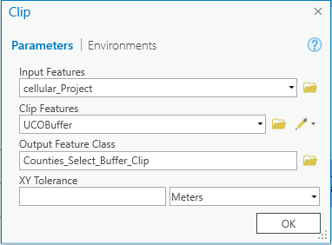

Figure 6 – The Clip tool in Model Builder.

### Step 6

Use the **Kernel Density** tool to compute the density of the towers in the clipped and projected cell tower data layer. Specify the **output** **cell size** to **100** or **200** and the **search radius** to **20000**. No population field data needs to be specified. Set the **Area Units** to **Square Kilometers** so that the output density raster will be in units of **towers/sq.-km**. If for any reason you are unable to edit this setting, you can pull this parameter out of the tool using a similar process used in Step 4. Right-click and select **Create variable**, **From Parameter**, then click **Area Units**. It will show a lighter blue bubble that you can open and edit directly.

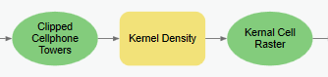

Figure 7 – The Kernel Density tool in Model Builder.

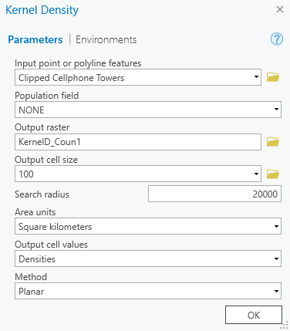

Figure 8 – Setting up the Kernel Density tool in Model Builder.

### Step 7

To identify the areas that meet the requirement of fewer than 20 towers per 10,000 km2, you must first convert the tower density units from km2 to 10,000 km2. This simply requires multiplying the tower density grid by 10,000. You will use a conditional statement to select those cells that are lower than the required 20 towers/10,000 km2 density.

Use the **Raster Calculator** tool to combine both functions in one line and place a “1” in the output cells that meet the required density. Use this following statement: **Con(10000 * "%Kernal Cell Raster%" < 20, 1, 0)**

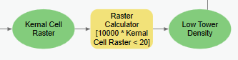

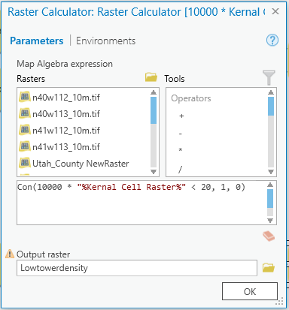

Figure 9 – The Raster Calculator in Model Builder.

### Step 9

With the suitable zones computed from the slope and road proximity requirement and the areas of low tower density identified, these two raster data sets can be combined into a single map. Use the **Raster Calculator** tool to multiply the two rasters together. This will result in an output raster that has “1” everywhere that meets the criteria and “0” in the places that do not meet the criteria. Use this statement to multiply the two raster data layers: **"%Suitable Slopes by roads%" * "%Low Tower Density%"**

Make sure to save your model because in a later lab you will need to access the work that you have done in this lab.

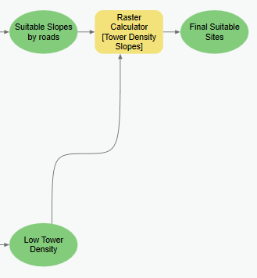

Figure 10 – The Raster Calculator tool in Model Builder.

## Deliverables

Using the given data, construct a ModelBuilder model that will prepare all your input data for the cellular phone tower analysis and conduct the analysis. As noted above, you are to find locations in Utah County that are the most suitable for the placement of new cell phone towers. Only consider the three given factors.

Prepare a brief report in Microsoft Word that contains a screen shot of your model that shows all elements of the model, a list of the steps that were taken in the model building process, and a final map of your results. Make sure to review the rubric for the full requirements of this lab exercise.

## References

Bolstad, P. (2008) GIS Fundamentals: A first Text on Geographic Information Systems. 3rd Edition. Esri Publishing.

U.S. Census Bureau. Population Profile of the United States. (2011) http://www.census.gov/population/www/pop-profile/profiledynamic.html.

U.S. Geological Survey. Geologic Provinces of the United States. (2011) http://geomaps.wr.usgs.gov/parks/province/rockymtn.html

## Example Map

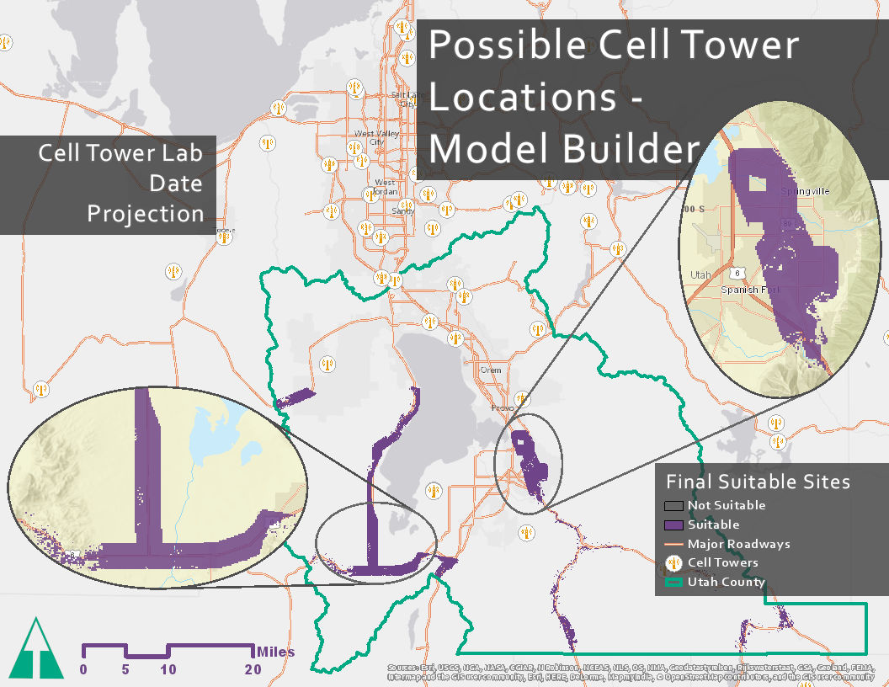

## Rubric for Cell Phone Tower Placement

|  |  |
| --- | --- |
| **Item** | **Points** |
| Assignment Title, Name, Date, Course | /1 |
| Brief report of the requirements of the project and why the project is useful | /5 |
| Describe your model   * List each of the tools used: (1 pt.) * List tool settings applied for the analysis (could someone repeat the assignment using your lab report?): (1 pt.) * List all input, intermediate, and output datasets: (1 pt.) * Describe each input dataset including type (point, line, polygon, raster) and the source of the data: (1 pt.) * Describe each output dataset (point, line, polygon, raster): (1 pt.) | /5 |
| * One or more full pages (8.5 x 11) showing your model (5 pts.) * All text in the graphics is readable (10pt. font minimum) (2 pts.) * All tools and datasets are shown (2 pts.) | /9 |
| * Describe the specific areas recommended for new towers. (3 pts.) * Do you agree with the results of the model or did you find anything different than expected? (2 pts.) | /5 |
| Make a full page (8.5 x 11) map showing the results of your cell tower analysis.   * Map Title: (1 pt.) * Neat Line: (1 pt.) * North Arrow: (1 pt.) * Scale Bar: (1 pt.) * Text box with author name, date, map projection: (1 pt.) * Suitable locations for new cell phone towers clearly shown: (5 pts.) * All datasets clearly symbolized: (1 pt.) * Visible base map showing road data: (1 pt.) * Data points showing existing cell phone towers: (1 pt.) * Zoomed to an appropriate scale for viewing analysis results: (1 pt.) * All text is legible on printed map: (1 pt.) | /15 |
| Create a Toolbox Interface for your model and include a screen capture of it including input and output data parameters. | /10 |
| **Bonus Task:** Repeat the lab exercise with a different dataset. Include in your report what data you used, how you acquired it, and what you may have changed to complete the exercise. Include an additional full-page map showing your results. | Instructor’s  Discretion |